**AV-101 Scan Operating Procedure**

**Set-up:**

* Have the subject fill out the MRI safety screening form in the control room—**ensure they are completely de-metaled**
* Provide the subject with ear plugs—the smaller ear plugs are pink-colored and located next to the cabinets closest to the window in the scanner room
* **Make sure you are de-metaled before entering the scan room** 
  + *If setting up alone, the pulse oximeter and respiratory belt are on the hooks behind the cabinets left of the scanner as you enter the room*
* Ask the subject to sit up on the MRI bed using the stool—be sure to check their ear plugs before you have them lie down
* Have the subject lie down and move their head up into the head coil
* Wrap the **respiratory belt** around their chest/abdomen and secure the Velcro
* Place the pulse oximeter on their **left index finger**, with the sensor under their finger
  + *Secure with medical tape wrapped around their index and middle finger*
* Give the subject the emergency squeeze bulb to hold in their dominant hand
* Place padding on either side of the subject’s head and slide the plastic mask over his/her face
* Use the light bulb button on the scan machine to landmark the laser at the brow ridge—press the button again to confirm the landmark
* Send the subject in using the I I button
* **Set up BIOPAC-physio computer** while tech is helping the subject into the scanner
  + Sign on to the Biopac username password: AcqKnowledge
  + Open Acknowledge 4.2 (on desktop)
  + Start new recording
    - Recent graph template
      * Belt B (usually the first option)
  + Click on MP150 tab on top of screen
    - Triggering🡪 make sure it is OFF ONLY FOR TEST
  + Click “**Start”** in the upper left corner to test the recording. Right-click the green recording(respiration) and select **“Autoscale waveforms”**
  + Hit “**Stop”** when you are satisfied
    - Go to Setup triggering and Turn triggering on, select “**CH8**” from the drop-down list
  + Click on MP150 tab on top of screen
    - Acquisition
      * Change seconds to minutes (11)
      * File 🡪 Click File and save as “Subjectinitials.date.0001” under **PhysioRecordings\ETPB\Nugent**
      * Set heart monitor interval to 1000
      * Hit close, new screen pops up check the incrementing minutes button
  + Hit start right before resting state begins
    - Window will pop up saying “wait for triggering” means that it will begin once the scan does
  + To view all waveforms on top row of graph, R click and hit autoscale
* On the scan computer, select **Patient**(located at Top Toolbar)🡪 **Scheduler**🡪Click subject’s name🡪Double-click “**MRI Limited**”
  + Enter Weight (on Order sheet), Study(**UserProtocols/Nugent**), Position(**Head first Supine**) and hit **Exam**
* Place labels from order sheet on scan log book and MRI safety screening form

**Scan:**

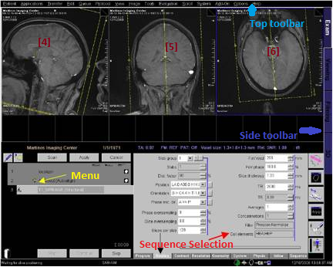

*Image adapted from Martinos Imaging Center website.*

*Periodically speak with patients asking them how they are doing and informing them of the time left in the scan—especially before longer scans*

* The session should be in **Exam** View on **Side Toolbar**
  + *If not, the tab is located on top right of side bar in black and purple*
* Hit Ctrl+Esc, select **SetSHIM.exe** and **CLEAR** all the shimming values before starting the first scan
* *Tell patient that first scan (Localizer + B1 Map) will be 1:30 min.*
* Select **AV101** under **ETPB** from **Sequence Selection** and move the **Localizer** sequence **<<** to the menu. Hit **Open**. Hit **Apply** to start the localizing scan
  + *In general, hit apply if you want to scan once; hit scan if you want to scan more than once*
  + *You will need to click “Continue” or “OK” on all the pre-scan dialog boxes*
* Move over **<<** **B1 map** to the menu hit **Open** and then **Apply**
  + *You will need to click “Continue” or “OK” on all the pre-scan dialog boxes*
* Once B1 map has completed, drag head icon next to B1 from menu to left display window and record temperature value[In Volts] from the bottom of the image onto the run sheet
* Move over **<<ANAT MPRAGE** to the menu, and hit **Open**
* Drag the head icon next to localizer to the left display window ([4]) and check to see that the brain is within the field for the anatomical scan
* Go to **Options**(located at Top Toolbar)**🡪Adjustments🡪Transmitter🡪[Input the value from B1 map at top right text box]🡪 Apply🡪Close**
  + *This will change the transmitter amplitude.*
* *Tell patient that scan will be 7 min.*
* Hit **Apply** and it will start the ANAT MPRAGE anatomical scan
  + *You will need to click “Continue” or “OK” on all the pre-scan dialog boxes*
* Move over <<**ANAT_NORM_PD** to the menu and hit **Open**
* Right-click “**Copy Parameters**” on ANAT MPRAGE🡪Select **Center of Slice**🡪Hit Ok
* *Tell patient that scan will be ~5 min*.
* Hit **Apply** and it will scan through the proton density scan
* Once you see the head icon next to ANAT MPRAGE, go to **3D** on **Side Toolbar**
  + Go to **Patient** (located at Top Toolbar)**🡪Patient Browser 🡪Local Database**. Drag ANAT MPRAGE [4] to the **3D** viewing window
    - Click “**Yes”** when prompted about loading a new sequence
  + Click on top left button under **Settings**, called “**Parallel Ranges”**
  + Change distance between image to **1.0 mm** (Hit enter after)
  + Hit button at top right, “**Constant Images**” to make slice distance constant
    - *Button should turn from white to grey*
* Adjust the positioning of the slices in the display window to cover the whole brain and skull including cerebellum🡪hit **Start** and the “**Yes”** in the dialog box to save
  + Do the same for the coronal direction🡪 Hit **Start**, hit **Close**, and then **“Yes”** to save
* Go to **Exam🡪**Drag each of the anatomical images from **Patient Browser** to the display window (should be [4] [5] and [6] for left, center and right panel, respectively)

**Resting State Sequence**

* Move over **<<** **676b_5m_1p8mm_forward** to menu. Hit **Open** and adjust the yellow slice volume so that it encompasses the whole brain
  + ***Rotate* O *until there is whole brain coverage****—it is okay to leave out a little bit of cerebellum as long as you include the entire cerebral cortex*
* *Tell patient that next scan will be a series of short scans lasting ~5 min.*
* After placing the slice, Go to **Options**(located at Top Toolbar)**🡪Adjustments🡪3D Shim**
* Hit **Load Tune-up**(only first time),**Measure, Calculate, Apply** button in order
* Pull up the **ShimSet** window from the beginning of the scan, and hit **SetShims_3rd**
  + *The Measure-Calculate-Apply-Set(or MCAS) step will need to be done 3-4 times to ensure the shim coeffients in 1st, 2nd, 3rd order are converging*
* Go to **Frequency**, and hit **Go**. You will need to hit **Go** one more time before the frequency value converges, and then hit **Close**
* *Tell patient: next scan will be ~11 min long. Please keep eyes closed for during the duration of the scan, try not to fall asleep during this resting state.*
* Hit **Apply** to begin 676b_5m_1p8mm_forward
  + *You will need to click “Continue” or “OK” on all the pre-scan dialog boxes*
* Move over **<< 676b_sin_1p8mm_rest** to menu, Hit **Open**🡪Right-click “**Copy Parameters**” on 676b_5m_1p8mm_forward 🡪Select “**Center of Slice”**
* **DO NOT HIT APPLY yet**
* On the BIOPAC-Physio computer, hit **Start** to begin physio recording. A window saying “Waiting for scanner will pop up”

*Tell patient to have their eyes closed for the next 10 minutes, trying not to fall asleep during this resting state*

* Hit **Apply** to begin **676b_sin_1p8mm_rest**
  + *You will need to click “Continue” or “OK” on all the pre-scan dialog boxes*
* Hit **Stop** on physio recording once rest scan has completed
* Move over **<<** **676b_sin_1p8mm_reverse** to menu. Hit Open🡪Right-click “**Copy Parameters**” on 676b_sin_1p8mm_rest 🡪Select “**Center of Slice”** and hit OK
* Double click on the program and under Routine Tab, change the Phase Enc Dir. Click on the […] gray box to the left and rotate 180 degrees.This should change the direction from A>>P to P>>A.
* Hit **Apply** to begin
* Find the **“Inline Display”** icon near the **Side Toolbar**
  + *This will open a Prog Step window that will show you the EPI images in real-time—Check for distortion and noise (blurriness and patterned artifacts)*
* **CLEAR SHIMS in ShimSet—very important!**

**MRS sequence voxel (medial Prefrontal Cortex)-** *Place voxel during resting state*

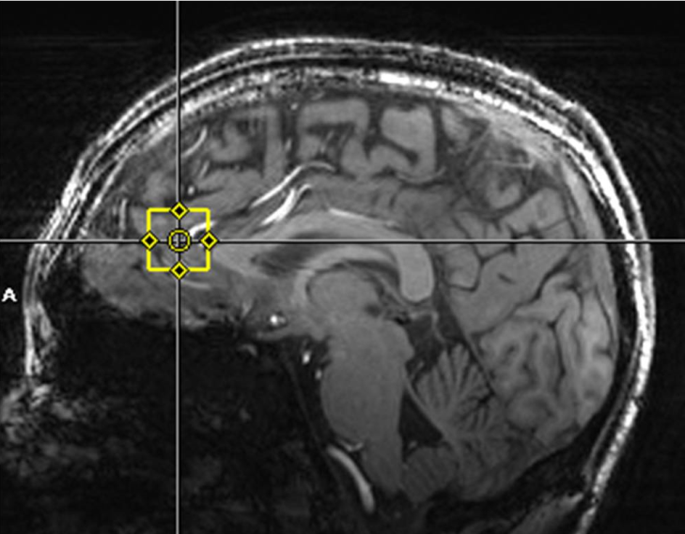

* *Tell patient there will be a series of short scans for a period of ~5 to 10 min.*
* Move over <<**FASTMAP** to the menu and hit **Open**, voxel should now appear
* Hit **Scan** once the voxel is placed in the desired location
  + *You will need to click “Continue” or “OK” on all the pre-scan dialog boxes*
* Hit ctrl +esc 🡪**Windows Explorer D:/LiAn/Software** and go to Li’s **Spectropeek.exe** software by double-clicking the application
  + **Only at baseline:** Open Screen Hunter in Li An Software folder (Under D Drive) to take pictures of voxel locations on [4] [5] and [6]
* Once FASTMAP has concluded, click on the FASTMAP tab in SpectroPeek and hit **Retrieve Shim values** (located at the top). Then **Apply shim coeffients**(located at the bottom)
  + Hit **Scan** once again for FASTMAP and **Apply shim coeffients** again till the slope of the line for shim values is flattened
* **Cancel** extra FASTMAP and move it to the trash in the lower left
* Move over **<<** **PRESS** to the menu, and hit **Open**
* Right-click already ran FASTMAP and select **“Copy Parameters”** 🡪”**Measurement Parameters”** and hit Ok
* Hit **Scan** for PRESS
* Once PRESS has concluded, click on the PRESS tab in SpectroPeek and hit **Retrieve** (located at the top left). Then **Set Frequency** (located at the top right)
  + *If setting the frequency fails, run PRESS again but hit Scan instead of Apply*
  + *Check the water linewidth on the press software, if it is too high (>15 hz), then you need to do the FASTMAP step again*
* **Cancel** extra PRESS and move it to the trash in the lower left
* Move over **<<** **B1 Profile** to the menu
* Right-click already ran PRESS and select **“Copy Parameters”** 🡪”**Measurement Parameters”** and hit Ok
* Hit **Scan** for B1 Profile
* Click on the B1 profile tab in SpectroPeek and hit **Retrieve** (located at the top left)
* On opened B1 Profile, Go to **Contrast** (on very bottom of Sequence selection area)🡪 Change flip angle
  + *Adjust the flip angle on B1 until VOI is centered as close to 0 as possible*
  + *Getting the voxel signal amplitude lower is preferable to getting it centered*
* Note down **Predicted voltage** top right corner of the B1 tab on the run sheet
* **Cancel** extra B1 Profile and move it to the trash in the lower left
* Drag press sequence down from menu, and hit **Open**
* Go to **System** (on very bottom of Sequence selection area)🡪**Adjustments🡪Change Voltage🡪[Enter Predicted Voltage from run sheet] – This will be found under Ref. on bottom left**
* Hit **Scan** for PRESS
* Once PRESS has concluded, click on the PRESS tab in SpectroPeek and hit **Retrieve** (located at the top). Then **Set Frequency**(located at the top right)
  + *If setting the frequency fails, run PRESS again but hit Scan instead of Apply*
  + Check the water linewidth on the press software, if it is too high (>15 hz), then you need to do the FASTMAP and B1 Profile step again
  + If the spectrum/linewidth looks good, write down the line width on run sheet. Units will be in Hz.
* To look at a water suppressed spectrum, go to Sequence Selectionand Click: **Sequence🡪Special🡪Adjust WS**
* Hit **Scan** for PRESS
* Once PRESS has concluded, click on the PRESS tab in SpectroPeek and hit **Retrieve** (located at the top).
  + If looks good continue, otherwise change water scaling factors on Sequence Selection or up the averages🡪retrieve data to check
* Go to **Options** in Sequence Selection 🡪 double check the voltage adjustment
* Go to **Sequence** in Sequence Selection **🡪Special🡪water interleaved** from the dropdown box
* Go to **Contrast🡪Averages🡪**[Change the value from 2 to **136**]
* *Tell patient that last scan will be 6 min*.
* Hit **Apply** for PRESS, should last ~6 minutes
* Once PRESS has concluded, click on the PRESS tab in SpectroPeek and hit **Retrieve** (located at the top). **DON’T FORGET TO DO THIS STEP TO SAVE**
  + If looks good, transfer data(see separate instructions)